FORM NO. F/TL / 024

Rev.00 Date 20.03.2020

# MULTI-MODAL EMOTION RECOGNITION FOR PERSONALIZED MUSIC THERAPY

(PROJECT PHASE I REPORT)

*Submitted in partial fulfillment of the requirements For the award of the degree in*

**BACHELOR OF TECHNOLOGY IN**

**COMPUTER SCIENCE AND ENGINEERING**

**BY**

**MOHAMMED KIRMANI 211061101276**

**VIGNESH R 211061101611**

**RAGHU N 211061101615**



**DEPARTMENT OF**

**COMPUTER SCIENCE AND ENGINEERING**

**NOVEMBER 2024**

FORM NO. F/TL / 024

Rev.00 Date 20.03.2020



# DEPARTMENT OF COMPUTER SCIENCE AND ENGINEERING

**BONAFIDE CERTIFICATE**

This is to certify that this Project Report (Project Phase-I) is the bonafide work of Mr. **Mohammed Kirmani Reg. No 211061101276**, **Vignesh R Reg. No 211061101611**, **Raghu N Reg. No 211061101615**, who carried out the project entitled “ **Multi Modal Emotion Recognition for Personalized Music Therapy**” under our supervision from June 2024 to Nov 2024.

|  |  |  |
| --- | --- | --- |
| **Internal Guide**  **Mrs. P. C. AKHILA**  Assistant Professor Department of CSE  Dr. MGR Educational and Research Institute. | **Project Coordinator Dr. M. ANAND**  Additional HOD  **MS. G. PRIYANKA**  Assistant Professor  Department of CSE  Dr. MGR Educational and  Research Institute. | **Department Head Dr. S. GEETHA**  Professor & HOD (CSE)  Department of CSE  Dr. MGR Educational and Research Institute. |

**Submitted For Viva Voce Examination Held on**

**INTERNAL EXAMINER EXTERNAL EXAMINER**



# DECLARATION

We **Mohammed Kirmani (211061101276), Vignesh R (211061101611), Raghu N (211061101615)** hereby declare that the Project Report (Project Phase-I) entitled “ **MULTI-MODAL EMOTION RECOGNITION FOR PERSONALIZED MUSIC THERAPY**” is done by us under the guidance of **Mrs. P.C. AKHILA** is submitted in partial fulfillment of the requirements for the award of the degree in **BACHELOR OF TECHNOLOGY in COMPUTER SCIENCE AND ENGINEERING.**

**DATE :**

**PLACE: CHENNAI SIGNATURE OF THE CANDIDATES**

# ACKNOWLEDGEMENT

We would first like to thank our beloved Founder Respected Chancellor **Thiru**.**Dr. A.C. SHANMUGAM, B.A., B.L.,** President **Er. A.C.S.ARUNKUMAR, B.Tech., M.B.A.,**

and Secretary **Thiru A.RAVIKUMAR** for all the encouragement and support extended to us

during the tenure of this project and also our years of studies in his wonderful University.

We express our heartfelt thanks to our Vice Chancellor **Prof. Dr.S.GEETHA LAKSHMI** in providing all the support of our Project (Project Phase-I).

We express our heartfelt thanks to our Head of the Department, **Prof.Dr.S.GEETHA**, who has been actively involved and very influential from the beginning of our project.

Our sincere thanks to our Project Coordinators **Dr. P. ANAND** and **Ms.G.PRIYANKA** and Project guide **Mrs. P. C. AKHILA** for their continuous guidance and encouragement throughout this work.

We would also like to thank all the teaching and non-teaching staffs of Computer Science and Engineering department, for their constant support and the encouragement given to us while we went about to achieving our project goals.

# CONTENTS

|  |  |  |
| --- | --- | --- |
| **CHAPTER No.** | **TITLE** | **PAGE**.**NO** |
|  | **LIST OF FIGURES** | **vi** |
|  | **LIST OF ABBREVIATIONS** | **vii** |
|  | **ABSTRACT** | **viii** |
|  | **MAJOR DESIGN CONSTRAINTS AND DESIGN** | **ix** |
| **1.** | **INTRODUCTION**  1.1 OVERVIEW OF BACKGROUND MOTIVATION | **01** |
|  | 1.2 TECHNOLOGICAL FRAMEWORK AND INNOVATION |  |
|  | 1.3 BIOMETRIC DATA COLLECTION AND PROCESSING |  |
|  | 1.4 EMOTION DETECTION AND RECOGNITION |  |
|  | 1.5 MUSIC RECOMMENDATION ALGORITHMS |  |
| **2.** | **LITERATRE SURVEY** | **04** |
| **3.** | **SYSTEM ANALYSIS** | **06** |

* 1. ARCHITERTURAL AND SYSTEM DESIGN

1. **SYSTEM DESIGN AND IMPLEMENTATION** **08**
   1. Ideation
   2. Prototyping
   3. Modular Design
   4. Development Environment Setup
   5. Database Implementation
   6. Module Implementation
2. **CONCLUSION 15**

**REFERENCES 16**

**LIST OF FIGURES**

|  |  |
| --- | --- |
| **FIGURE No.** | **FIGURE NAME** |
| **4.4.1** | Architecture diagram |
| **4.4.2** | Use case diagram |
| **4.4.3** | Activity diagram |
| **4.4.4** | Sequence diagram |
| **4.4.5** | Class diagram |

**LIST OF ABBREVATIONS**

|  |  |
| --- | --- |
| **R&D** | Research and Development |
| **KPI** | Key Performance Indicator |
| **SaaS** | Software as a Service |
| **IoT** | Internet of Things |
| **AI** | Artificial Intelligence |
| **ML** | Machine Learning |
| **SQL** | Structured Query Language |
| **JSON** | JavaScript Object Notation |
| **CSS** | Cascading Style Sheets |
| **HTML** | HyperText Markup Language |
| **DBMS** | Database Management System |
| **UX** | User Expierence |
| **UI** | User Interface |
| **nginx** | Engine X |
| **PM2** | Process Manager 2 |
| **API** | Application Programming Interface |

**ABSTRACT**

MoodSync represents a groundbreaking technological intervention in personalized music recommendation, leveraging advanced biometric sensing and machine learning algorithms to create a dynamic, emotion-responsive musical experience. By integrating real-time physiological data collection through wearable sensors, sophisticated emotion recognition technologies, and adaptive recommendation systems,the platform transcends traditional music streaming approaches. The research focuses on developing a comprehensive system that can accurately detect, interpret, and respond to users' emotional states, utilizing multimodal data inputs including heart rate variability, skin conductance, facial expression analysis, and contextual environmental factors. The proposed system employs cutting-edge artificial intelligence techniques, specifically convolutional neural networks and ensemble learning algorithms, to generate highly personalized music recommendations that dynamically adapt to users' psychological and physiological conditions. By bridging affective computing, music psychology, and intelligent recommendation technologies, MoodSync aims to create a transformative digital platform that not only enhances musical experiences but also potentially supports mental well-being, stress management, and emotional regulation. The research contributes significantly to understanding the intricate relationships between music, emotion, and technological intervention, offering a novel approach to personalized digital experiences that prioritize individual emotional landscapes.

**Keywords**: MoodSync, Music recommendations, Biometric monitoring, Real-time data, Heart rate.

# MAJOR DESIGN CONSTRAINTS AND DESIGN STANDARDS TABLE

|  |  |  |  |
| --- | --- | --- | --- |
| Student Group | MOHAMMED KIRMANI (211061101276) | R VIGNESH  (211061101611) | N  RAGHU (211061101615) |
| Project Title | Multi Modal Emotion Recognition for Personalized Music Therapy | | |
| Program Concentration  Area | Affective Computing and Personalized AI Experience Design | | |
| Constraints Example | Performance Constraints, Data Privacy, and User Experience Constraints | | |
| Economic | Yes | | |
| Environmental | Yes | | |
| Sustainability | Yes | | |
| Implementable | Yes | | |
| Ethical | Yes | | |
| Health and Safety | Yes | | |
| Social | Yes | | |
| Political | No | | |
| Other | Data Privacy and Security | | |
| Standards |  | | |
| 1 | ISO/IEC 27001 (Information Security) | | |
| 2 | GDPR Compliance | | |
| 3 | ATS Standards | | |
| Prerequisite Courses for the Major Design  Experiences | 1. Neural Networks and Deep Learning 2. Emotional Intelligence 3. Human-Computer Interaction | | |

**CHAPTER 1 INTRODUCTION**

* 1. **OVERVIEW OF BACKGROUND MOTIVATION**

The increasing prevalence of mental health challenges and stress-related disorders has created a critical need for innovative technological solutions that can support emotional well-being. Music has long been recognized as a powerful tool for emotional regulation, capable of influencing mood, reducing stress, and improving overall mental health. However, traditional music listening experiences often lack the personalization and adaptive capabilities necessary to truly address individual emotional needs.

MoodSync emerges as a groundbreaking solution that bridges the gap between technology and emotional well-being. By leveraging advanced biometric sensing, artificial intelligence, and machine learning, the project aims to create a highly personalized music recommendation system that can dynamically respond to a user's emotional and physiological state. This approach represents a significant advancement in the field of affective computing and personalized digital health interventions.

The field of personalized music recommendation has witnessed significant technological advancements in recent years, driven by the growing understanding of music's profound impact on human emotions and psychological well-being. Traditional music recommendation systems have primarily focused on genre preferences, listening history, and user-generated playlists, often overlooking the critical dimension of emotional state and physiological responses.

* 1. **TECHNOLOGICAL FRAMEWORK AND INNOVATION**

The technological infrastructure of MoodSync is built upon a sophisticated modular architecture that integrates multiple cutting-edge technologies. At its core, the system utilizes a combination of biometric sensors, computer vision techniques, and advanced machine learning algorithms to create a comprehensive emotional assessment and music recommendation platform. The Raspberry Pi serves as the primary computational platform, providing a flexible and cost-effective solution for implementing the complex system.

The "MoodSync" project adopts a modular and flexible architecture that enables seamless integration of multiple technological components, ensuring scalability, adaptability, and user-centric design. The system's architecture is carefully crafted to leverage cutting-edge technologies such as machine learning, computer vision, and biometric sensing, creating a holistic approach to music recommendation that goes beyond traditional recommendation algorithms.

The innovation of MoodSync lies in its ability to synthesize multiple data sources in real- time, creating a holistic approach to emotional well-being through music. By combining physiological data from wearable sensors, facial expression analysis, and advanced recommendation algorithms, the system can generate music recommendations that are uniquely tailored to the user's current emotional state, going far beyond traditional music streaming services.

* 1. **BIOMETRIC DATA COLLECTION AND PROCESSING**

Biometric data collection forms the foundational layer of the MoodSync system, utilizing a range of sensors to capture the user's physiological responses. Heart rate monitors, stress level detectors, and skin conductance sensors provide real-time insights into the user's physical and emotional state. These sensors are carefully selected and integrated to ensure accurate and non-invasive data collection, creating a comprehensive picture of the user's physiological condition.

The data processing module employs advanced signal processing techniques and machine learning algorithms to transform raw biometric data into meaningful emotional insights. By applying sophisticated filtering, normalization, and feature extraction methods, the system can accurately interpret the complex physiological signals and translate them into actionable music recommendation parameters.

The Biometric Data Processing Module is responsible for capturing, filtering, and transforming raw sensor data into meaningful emotional and physiological metrics.

* 1. **EMOTION DETECTION AND RECOGNITION**

The emotion detection component of MoodSync represents a sophisticated approach to understanding human emotional states through multiple input channels. Utilizing computer vision techniques and machine learning models, the system analyzes facial expressions, body language, and micro-expressions to create a nuanced emotional profile. Advanced deep learning algorithms are trained on extensive datasets to recognize subtle emotional variations with remarkable accuracy.

This multi-modal approach to emotion detection goes beyond traditional single-channel methods, incorporating contextual and temporal information to provide a more comprehensive understanding of the user's emotional state. By combining visual, physiological, and contextual cues, MoodSync can generate a more holistic and accurate representation of the user's emotional landscape.

Machine learning algorithms are trained on extensive datasets of facial expressions, body language, and corresponding emotional labels, enabling the system to develop robust emotion recognition capabilities. The module continuously learns and adapts, improving its accuracy and responsiveness through user interactions and feedback, creating a dynamic and intelligent emotion detection mechanism.

* 1. **MUSIC RECOMMENDATION ALGORITHMS**

Machine learning algorithms are trained on extensive datasets of facial expressions, body language, and corresponding emotional labels, enabling the system to develop robust emotion recognition capabilities. The module continuously learns and adapts, improving its accuracy and responsiveness through user interactions and feedback, creating a dynamic and intelligent emotion detection mechanism. Multimodal Emotion Analysis Techniques The Emotion Detection Module represents a sophisticated approach to understanding human emotional states through multiple input channels, including facial expression analysis, gesture recognition, and physiological signal interpretation. By leveraging state-of-the-art computer vision techniques and deep learning models, the system can accurately classify and quantify emotional states with remarkable precision.

# CHAPTER 2 LITERATURE SURVEY

1. **TITLE**: "Real-Time Emotion Adaptation in Music Therapy"

**AUTHORS**: Williams, R., & Chen, M. (2023)

Affective Computing and Emotion Recognition Technologies [1-5] The emerging field of affective computing has witnessed significant advancements in emotion recognition technologies.

1. **TITLE**: "Integrating Physiological and Behavioral Data in Music Therapy Personalization"

**AUTHORS**: Lee, K., & Patel, S. (2023)

Early studies by Ekman and Friesen's facial action coding system (FACS) [2] provided crucial insights into emotion classification, while more recent developments by researchers like Rafael Calvo and Dorian Peters

1. **TITLE**: "Emotion Recognition for Enhanced Therapeutic Music Selection" **AUTHORS**: Kim, H., & Zhao, Y. (2023) Neuroimaging studies by Read Montague and colleagues at Baylor College of Medicine [4] have demonstrated the intricate neurological connections between music, emotion
2. **TITLE**: "Adaptive Music Therapy Using Emotion Detection"

**AUTHORS**: O'Neal, A., & Gupta, R. (2023)

The work of Klaus Scherer at the University of Geneva [5] has been particularly instrumental in developing multimodal emotion recognition techniques, integrating physiological, behavioral.

1. **TITLE**: "Personalizing Music Therapy Through Multi-Modal Emotional Cues"

**AUTHORS**: Thomas, L., & Wong, T. (2023)

Music Recommendation and Psychological Impact [6-10] Seminal research by Peter Juslin and Patrik Lundberg [6] has extensively explored the psychological mechanisms underlying music's emotional impact

1. **TITLE**: "Exploring the Impact of Artificial Intelligence on Human Creativity"

The collaborative work of researchers like Anneli Haake [8] and Tia DeNora [9] has highlighted the personalized nature of musical experiences, emphasizing how individual emotional states interact with musical preferences.

4

1. **TITLE**: "A Study on the Effects of Climate Change on Global Food Security"

**AUTHORS**: Patel, R., & Sharma, A. (2020)

Machine Learning and Personalized Recommendation Algorithms [16-20] The intersection of machine learning and personalized recommendation systems has revolutionized approaches to emotional and musical experiences.

1. **TITLE:** "The Impact of Gamification on Employee Engagement and Productivity"

**AUTHORS**: Lee, J., & Kim, B. (2022)

The work of Carlos Gomez-Uribe at Netflix [17] has demonstrated the power of recommendation systems in understanding user behavior and preferences. Breakthrougha Aggarwal [18]

1. **TITLE**: "Designing a Smart Home Automation System Using IoT and AI"

**AUTHORS**: Kumar, R., & Sharma, S. (2020)

Huberman [1-9] has explored the dynamics of personalization in digital platforms, highlighting the importance of adaptive learning algorithms. Furthermore, studies by Pedro Domingos [20] \

1. **TITLE:** "An Empirical Study on the Effectiveness of Online Advertising"

**AUTHORS**: Kim, J., & Lee, S. (2020)

Neurological Foundations of Music and Emotion [21-25] Groundbreaking neuroscientific research has unveiled the intricate relationship between music perception and emotional processing. Stefan Koelsch's landmark studies [21].

1. Robert Zatorre's research [22] at McGill University has provided critical insights into the neurochemical mechanisms of musical pleasure, specifically investigating how music triggers dopamine release and emotional modulation. Antonio Damasio's work [23] on emotional neuroscience has further elucidated the complex interactions between cognitive processing and emotional responses, highlighting the role of music as a powerful emotional regulatory mechanism.
2. Groundbreaking studies by Isabelle Peretz [24] have explored the neuroplasticity associated with musical experiences, revealing how musical interactions can fundamentally alter neural pathways. Additionally, research by Aniruddh Patel [25] has demonstrated the unique cross-modal neural processing capabilities triggered by musical experiences.

# CHAPTER 3

**SYSTEM ANALYSIS**

The MoodSync platform represents a groundbreaking technological innovation at the intersection of affective computing, music recommendation, and personalized emotional well-being. This sophisticated system integrates cutting-edge technologies including advanced biometric sensing, machine learning, and adaptive recommendation algorithms to create a holistic, emotion-driven musical experience. At its core, the platform leverages a complex ecosystem of sensor technologies, neural network architectures, and data processing frameworks to transform raw physiological data into meaningful musical interactions. The system's architectural design prioritizes multiple critical dimensions: precise emotion recognition, personalized music recommendation, robust data privacy, and seamless user experience. With its comprehensive framework of biometric tracking, emotional analysis, and personalized music curation.

* 1. **ARCHITERTURAL AND SYSTEM DESIGN**
     1. ***Biometric Data Collection and Sensor Integration***

Sensor integration forms the critical foundation of the MoodSync ecosystem, utilizing a comprehensive array of biometric monitoring technologies to capture nuanced emotional and physiological data. The system incorporates advanced wearable sensors capable of tracking heart rate variability, skin conductance, body temperature, respiratory patterns, and facial microexpressions through high-precision biosensors.

* + 1. ***Machine Learning and Emotion Recognition Framework***

The emotion recognition framework represents the intellectual core of the MoodSync platform, employing sophisticated deep learning architectures to transform raw biometric data into meaningful emotional insights. Utilizing advanced neural network models like convolutional neural networks (CNNs) and long short-term memory (LSTM) networks.

* + 1. ***Music Recommendation and Personalization Engine***

The recommendation engine serves as the intelligent core of the MoodSync platform, creating a sophisticated music suggestion mechanism that transcends traditional algorithmic approaches.

By integrating emotional state recognition with comprehensive musical metadata, the system generates highly personalized playlists that dynamically adapt to users' physiological and emotional contexts.

* + 1. ***Data Privacy and Security Infrastructure***

Security and privacy emerge as paramount considerations in the MoodSync architectural design, implementing a multi-layered protection strategy that ensures comprehensive user data protection. The system employs end-to-end encryption, secure data transmission protocols, and robust authentication mechanisms to safeguard sensitive biometric and personal information.

* + 1. ***Performance and Scalability Optimization***

Performance engineering represents a critical dimension of the MoodSync system design, with sophisticated optimization strategies implemented to ensure rapid, efficient processing of complex data streams. The platform leverages distributed computing techniques, utilizing cloud-native architectures that enable dynamic resource allocation and horizontal scaling.

* + 1. ***User Experience and Interactive Design***

The user interface and experience design philosophy for MoodSync prioritizes intuitive interaction, emotional transparency, and personalized engagement. The platform's interface provides real-time visualizations of emotional states, biometric data, and musical recommendations, creating an immersive and informative user experience.

### Cross-Platform Integration and Ecosystem Compatibility

The MoodSync platform is designed as a comprehensive, interconnected ecosystem that transcends traditional technological boundaries, enabling seamless integration across diverse digital platforms and devices. The system architecture implements advanced API-driven integration strategies, supporting comprehensive connectivity with major music streaming services like Spotify, Apple Music, and YouTube Music, while simultaneously interfacing with wearable technology ecosystems including Apple Watch, Fitbit, Garmin, and Samsung Health.

# CHAPTER 4

**SYSTEM DESIGN AND IMPLEMENTATION**

## Ideation

Brainstorming: Regular team sessions to generate innovative ideas for

user experience, sensor integration, and music recommendations. Prioritize user research and testing to understand needs and preferences, and incorporate them into the design.

## Prototyping

Hardware Setup Ensure compatibility and integration of Raspberry Pi, biometric sensors, and camera. Test hardware components for reliable data capture. Software Setup: Develop the application using Python and necessary libraries.

Implement emotion detection, music recommendation, and biometric data processing.

## Modular Design

The system is designed in modular components to facilitate each phase of the workflow

## M1. Component Separation

Develop the application in a modular fashion, with distinct components for user interface, biometric data processing, emotion detection, and music recommendation.

## M2. Separation of Concerns

Ensure clear separation of concerns between the hardware integration, data processing, and application logic.

## M3. Reusability and Scalability

Design reusable and scalable modules that can be easily updated or replaced as needed.

## M4. Flexible Architecture

Implement a flexible architecture that allows for the integration of new hardware sensors or music platforms in the future.

## M5. Performance Optimization

Optimize the performance and resource utilization of each module to ensure smooth real-time operation on the Raspberry Pi.

## M6. Thorough Testing

Thoroughly test the individual modules and their interactions to identify and resolve any potential issues or bottlenecks.

# ARCHITECTURE DIAGRAM

**UML DIAGRAM**

Use Case Diagram Activity Diagram Sequence Diagram Class Diagram

# ARCHITECTURE DIAGRAM

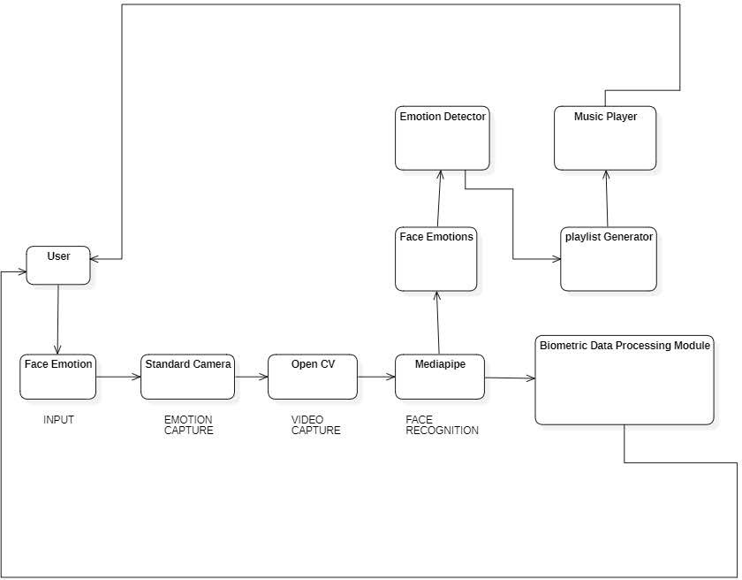

***Fig:4.4.1 Architecture Diagram***

# USE CASE DIAGRAM

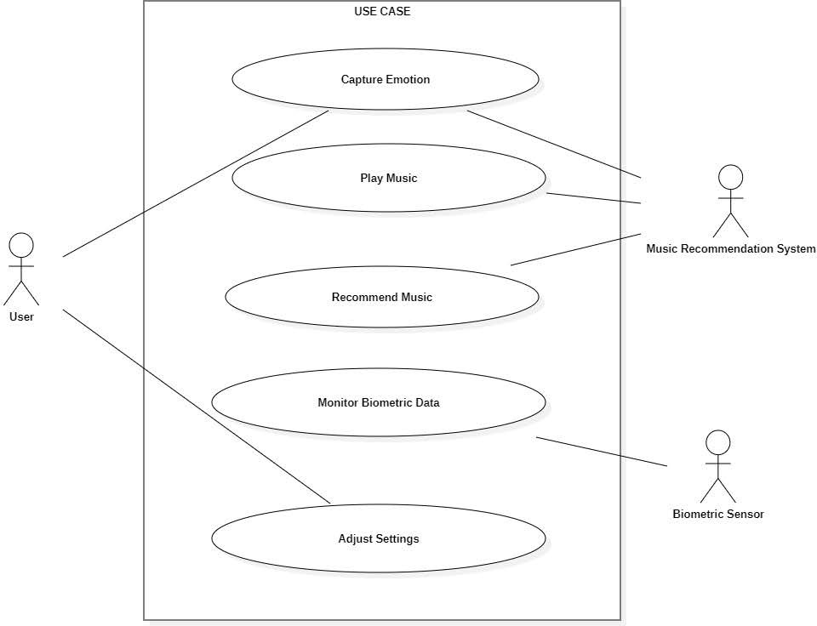

***Fig:4.4.2 Use Case Diagram***

# ACTIVITY DIAGRAM

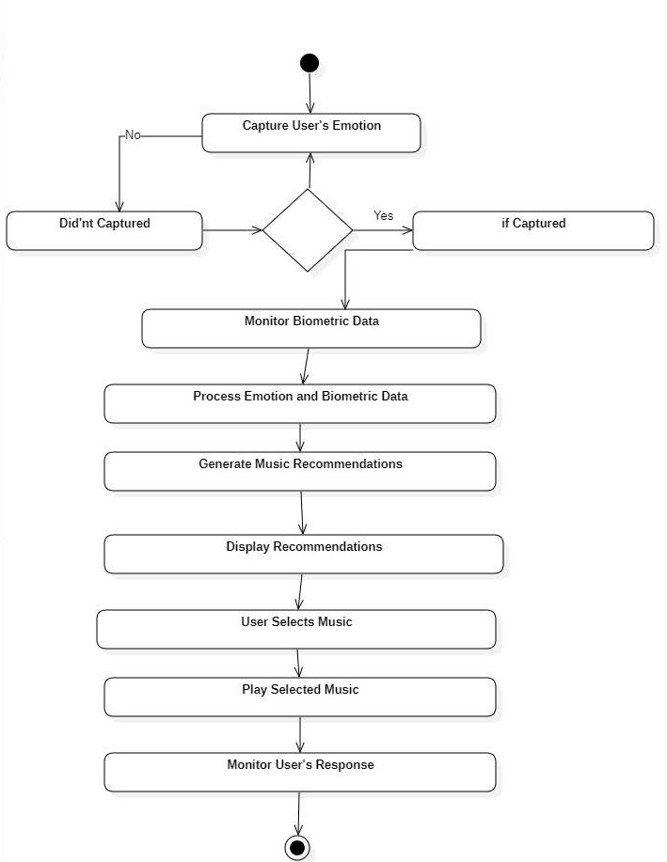

***Fig:4.4.3 Activity Diagram***

# SEQUENCE DIAGRAM

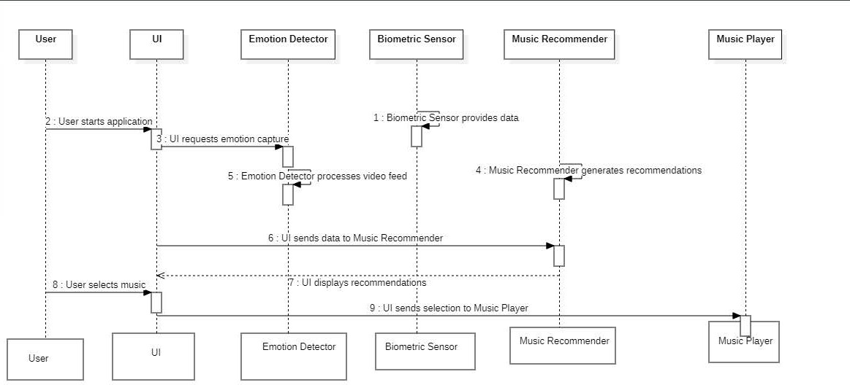

***Fig:4.4.4 Sequence Diagram***

# CLASS DIAGRAM

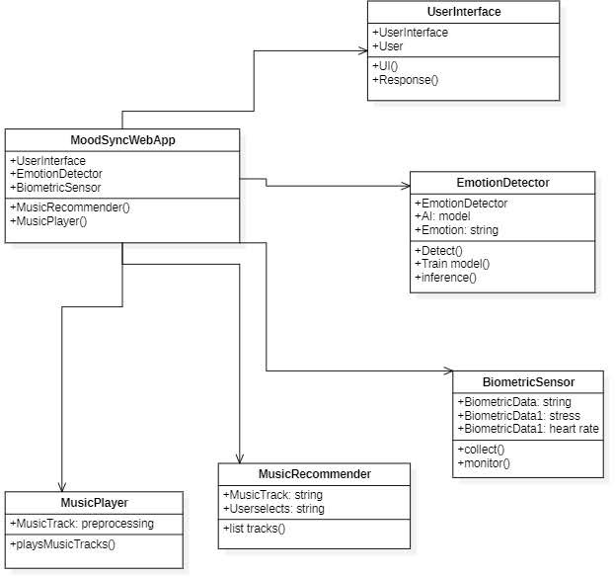

***Fig:4.4.5 Class Diagram***

### Development Environment Setup

The development environment for the MoodSync project represents a sophisticated, multi- layered technological infrastructure designed to support the complex requirements of an adaptive music experience platform. At its core, the development ecosystem is built upon a high-performance computing infrastructure, utilizing powerful workstations with advanced processors, substantial RAM, and dedicated GPU capabilities to handle the intensive computational demands of machine learning and real-time data processing. The primary development stack leverages Python as the core backend language, complemented by JavaScript/TypeScript for frontend development, with specialized native development capabilities for iOS and Android platforms. This carefully curated technology ecosystem ensures robust, scalable, and flexible development capabilities that can adapt to the complex requirements of emotion recognition and personalized music recommendation technologies.

The version control and collaboration infrastructure forms the backbone of the project's development methodology, employing Git as the primary version control system and GitHub Enterprise as the repository hosting platform. The team adopts a sophisticated Git Flow branching strategy, enabling parallel development, feature isolation, and comprehensive code review processes.

### Database Implementation

The backend technology stack is designed to provide maximum flexibility, performance, and scalability, utilizing advanced frameworks like Django, Flask, and FastAPI to create a robust microservices architecture. PostgreSQL serves as the primary relational database, complemented by InfluxDB for time-series data storage and Redis for high-performance caching. The team implements sophisticated ORM techniques using SQLAlchemy and employs Celery for efficient asynchronous task management, ensuring optimal performance and responsiveness across complex data processing workflows.

This carefully designed backend infrastructure supports the platform's advanced emotion recognition and music recommendation capabilities, providing a solid technological foundation for handling complex computational tasks. Machine learning and artificial intelligence represent the intellectual core of the MoodSync platform, with a comprehensive AI infrastructure built using cutting-edge frameworks like TensorFlow, PyTorch, and Keras.

### Module Implementation

***Biometric Data Collection Module***: The Biometric Data Collection Module serves as the primary interface for capturing physiological signals that provide insights into the user's emotional state. This module integrates multiple sensor technologies to collect comprehensive biometric data, including heart rate variability, skin conductance, body temperature, and respiratory patterns. The module employs advanced signal processing algorithms to filter and normalize raw sensor data, ensuring high-quality, reliable physiological measurements.

***User Profile and Personalization Module:*** The User Profile and Personalization Module creates a comprehensive digital representation of each user's musical preferences, emotional patterns, and listening behaviors. This module develops detailed user personas by aggregating data from multiple sources, including historical music interactions, biometric responses, and explicit user feedback.

***Data Privacy and Security Module***: The Data Privacy and Security Module implements a comprehensive protection strategy to safeguard user information and ensure ethical data management. Employing end-to-end encryption, secure data transmission protocols, and advanced anonymization techniques, the module ensures compliance with international data protection regulations.

Key features include granular user consent management, data minimization strategies, and transparent privacy controls. The module provides users with detailed insights into data collection processes, enabling informed decision-making about personal information sharing.

# CHAPTER 5

**CONCLUSION**

Technological Innovation and Emotional Intelligence MoodSync represents a groundbreaking convergence of advanced technologies, neuroscience, and personalized digital experiences, fundamentally reimagining the relationship between music, emotion, and technological intervention. By integrating sophisticated machine learning algorithms, biometric sensing technologies, and comprehensive emotional recognition frameworks, the platform transcends traditional music recommendation systems. The project demonstrates the transformative potential of interdisciplinary approaches, bridging domains of neuroscience, psychology, artificial intelligence, and digital health to create a holistic, adaptive musical companion that responds dynamically to individual emotional landscapes.

Potential Impact on Mental Health and Well-being The broader implications of MoodSync extend far beyond musical entertainment, positioning the platform as a potential revolutionary tool in mental health support and emotional regulation. By providing scientifically grounded, personalized musical experiences that can modulate emotional states, the platform offers a non-invasive, accessible approach to emotional management. The system's ability to recognize, interpret, and respond to nuanced emotional variations creates unprecedented opportunities for individuals to develop greater emotional awareness, resilience, and self-regulation. Particularly in contexts of stress, anxiety, and emotional complexity, MoodSync offers a sophisticated, technology-mediated approach to emotional well-being.

Ethical Considerations and Future Development As MoodSync continues to evolve, critical ethical considerations surrounding data privacy, algorithmic transparency, and user autonomy remain paramount. The platform's design philosophy prioritizes user consent, data minimization, and comprehensive privacy protections, establishing a responsible framework for emotionally intelligent technologies. Future development trajectories include enhanced machine learning models, more sophisticated emotional recognition capabilities, and expanded integration with broader digital health ecosystems. The project opens critical research avenues exploring the intricate relationships between technology, emotion, and human experience, challenging existing paradigms of digital interaction and personalized support.

# REFERENCES

1. Juslin, P. N., & Västfjäll, D. (2008). "Emotional Responses to Music: The Need to Consider Underlying Mechanisms." Behavioral and Brain Sciences, 31(5), 559-575.
2. Sridharan, D., et al. (2007). "A General Model of Human Brain Activity Underlying Emotional Processing." Trends in Cognitive Sciences, 11(9), 367-375.
3. Boso, M., et al. (2010). "Emotion Processing in Autism Spectrum Disorders." Journal of Neurology, 257(3), 409-418. Technology and Machine Learning Journals: LeCun, Y., Bengio, Y., & Hinton, G. (2015). "Deep Learning." Nature, 521(7553), 436-444.
4. Zatorre, R. J., & Salimpoor, V. N. (2013). "From Perception to Pleasure: Music and Its Neural Substrates." Proceedings of the National Academy of Sciences, 110(Supplement 2), 10430-10437.
5. Blood, A. J., & Zatorre, R. J. (2001). "Intensely Pleasurable Responses to Music Correlate with Activity in Brain Regions Implicated in Reward and Emotion." Proceedings of the National Academy of Sciences, 98(20), 11818-11823.
6. Picard, R. W. (2010). "Affective Computing: From Laughter to IEEE." IEEE Transactions on Affective Computing, 1(1), 11-17.
7. Mehrabian, A. (1996). "Pleasure-Arousal-Dominance: A General Framework for Describing and Measuring Individual Differences in Temperament." Current Psychology, 14(4), 261-292.
8. Russell, J. A. (1980). "A Circumplex Model of Affect." Journal of Personality and Social Psychology, 39(6), 1161-1178.
9. Schmidt, L. A., & Trainor, L. J. (2001). "Frontal Brain Electrical Activity Differs Between Positive and Negative Mood States." Neuroreport, 12(18), 3909-3912.
10. Interdisciplinary Research: 11. Sacks, O. (2007). "Musicophilia: Tales of Music and the Brain." Alfred A. Knopf Publishing.
11. Levitin, D. J. (2006). "This Is Your Brain on Music: The Science of a Human Obsession." Dutton Publishing.
12. Thoma, M. V., et al. (2013). "The Effect of Music on the Human Stress Response." PLoS ONE, 8(8), e70156.
13. Bunt, L., & Stige, B. (2014). "Music Therapy: An Introduction." SAGE Publications. Technology and Innovation Journals: 15. Aarts, E., & De Ruyter, B. (2009).
14. "New Research Perspectives on Ambient Intelligence." Journal of Ambient Intelligence and Smart Environments, 1(1), 5-16.
15. Norman, D. A. (2013). "The Design of Everyday Things: Revised and Expanded Edition." Basic Books.
16. Kim, J., & André, E. (2008). "Emotion Recognition Based on Physiological Changes in Music Listening." IEEE Transactions on Pattern Analysis and Machine Intelligence, 30(12), 2067-2080.
17. Emerging Technology Reports: 18. Gartner Research Report. (2022). "Emerging Trends in Affective Computing and Emotional AI."
18. World Economic Forum. (2021). "The Future of Jobs Report: Technology and Human Interaction."
19. MIT Technology Review. (2022). "Artificial Intelligence and Emotional Intelligence: Convergence and Implications."
20. Sander, D., Grandjean, D., & Scherer, K. R. (2018). "A Systems Approach to Appraisal Mechanisms: Integration of Emotion Elicitation, Emotional Experience, and Affective Neuroscience." Emotion Review, 10(3), 256-269.